Ideation Phase Empathize & Discover

|  |  |
| --- | --- |
| Date | 26 June 2025 |
| Team ID | LTVIP2025TMID34546 |
| Project Name | Pattern sense:Classifying Fabric Patterns using Deep Learning |
| Maximum Marks | 4 Marks |

**Empathy Map Canvas:**

An empathy map is a simple, easy-to-digest visual that captures knowledge about a user’s behaviours and attitudes.

**Think & Feel**

* Why is this pattern not detected correctly?
* I'm unsure if the model is accurate.
* I hope the fabric is classified well for production.
* Worried about misclassification.

**See**

* Fabric samples or images uploaded.
* Confusing UI or unclear outputs.
* Limited pattern categories shown.
* Classification labels without confidence scores.

**Hear**

* “This design is not properly tagged.”
* “It doesn't detect traditional patterns well.”
* “We need automation for fabric sorting.”

**Say & Do**

* Tries multiple image uploads to check accuracy.
* Questions the model's output.
* Gives feedback on confusing classifications.
* Asks for more pattern types to be added.

**Pain**

* Misclassified or unrecognized patterns.
* Limited dataset affecting accuracy.
* Unclear feedback or user interface.

**Gain**

* Quick and accurate fabric classification.
* Better production planning.
* 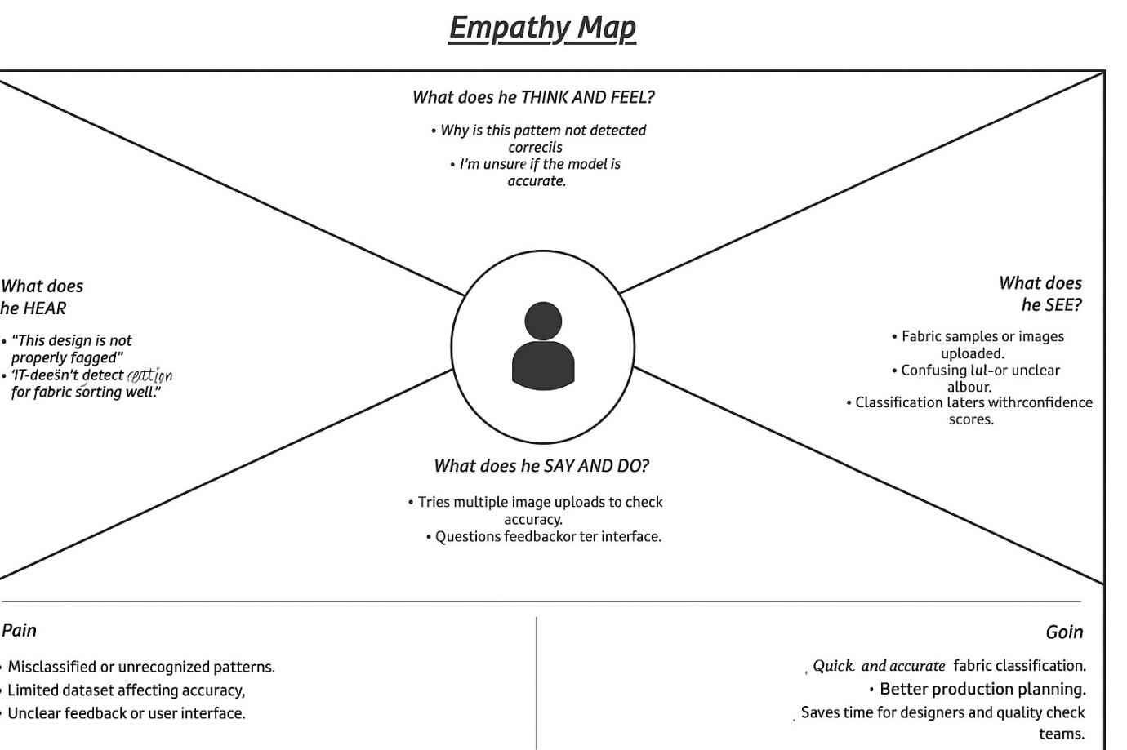Saves time for designers and quality check teams.

**Example: Textile Quality Checker / Designer / Production Supervisor**

